**Use RDP to connect to Windows Azure virtual machines**

## What is the Remote Desktop Protocol?

* Remote Desktop (RDP) provides remote connectivity to the UI of Windows-based computers.
* RDP enables you to sign in to a remote physical or virtual Windows computer.
* An RDP connection enables you to carry out the vast majority of operations that you can do from the console of a physical computer.
* An RDP connection requires an RDP client. Microsoft provides RDP clients for the following operating systems:
* Windows (built-in)
* macOS
* iOS
* Android

The following screenshot displays the Remote Desktop Protocol client in Windows 10.

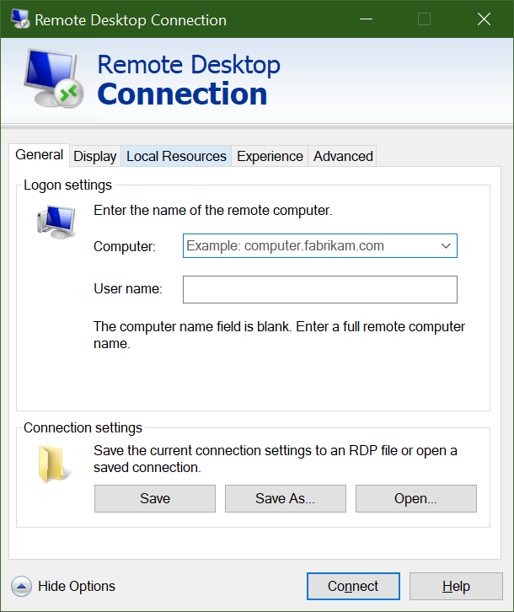

### How do you connect to a VM in Azure using RDP?

Connecting to a VM in Azure using RDP is a simple process. In the Azure portal, you go to the properties of your VM, and at the top, click **Connect**. This will show you the IP addresses assigned to the VM and give you the option to download a **preconfigured.rdp** file that Windows then opens in the RDP client. You can choose to connect over the public IP address of the VM in the RDP file. Instead, if you're connecting over VPN or ExpressRoute, you can select the internal IP address. You can also select the port number for the connection.

If you're using a static public IP address for the VM, you can save the **.rdp** file to your desktop. If you're using dynamic IP addressing, the **.rdp** file only remains valid while the VM is running. If you stop and restart the VM, you must download another **.rdp** file.

***Tip***

*You can also enter the public IP address of the VM into the Windows RDP client and click****Connect****.*

When you connect, you'll typically receive two warnings. These are:

* **Publisher warning** - caused by the **.rdp** file not being publicly signed.
* **Certificate warning** - caused by the machine certificate not being trusted.

In test environments, these warnings can be ignored. In production environments, the **.rdp** file can be signed using **RDPSIGN.EXE** and the machine certificate placed in the client's **Trusted Root Certification Authorities** stor

# Connect to a Windows virtual machine using RDP

To connect to an Azure VM with an RDP client, you will need:

* Public IP address of the VM (or private if the VM is configured to connect to your network)
* Port number

You can enter this information into the RDP client, or download a pre-configured **RDP** file.

***Note***

*An****RDP****file is a text file that contains a set of name/value pairs that define the connection parameters for an RDP client to connect to a remote computer using the Remote Desktop Protocol.*

### Download the RDP file

1. In the [Azure portal](https://portal.azure.com/learn.docs.microsoft.com), ensure the **Overview** pane for the virtual machine that you created earlier is open. You can also find the VM on the Azure **home** page, under **All Resources**, if you need to open it. The **Overview** pane has a lot of information about the VM.
   * You can see whether the VM is running.
   * Stop or restart it.
   * Get the public IP address to connect to the VM.
   * See the activity of the CPU, disk, and network.
2. In the top menu bar, select **Connect**, and from the dropdown list, select **RDP**. The **Connect** pane appears for your virtual machine.
3. Note the **IP address** and **Port number** settings, then select **Download RDP File**, and save it to your computer.
4. Before we connect, let's adjust a few settings. On Windows, find the file using Explorer, right-click, and select **Edit**. On macOS you will need to open the file first with the RDP client and then right-click on the item in the displayed list and select **Edit**.
5. You can adjust a variety of settings to control the experience in connecting to the Azure VM. The settings you will want to examine are:
   * **Display**: By default, it will be full screen. You can change this to a lower resolution, or use all your monitors if you have more than one.
   * **Local Resources**: You can share local drives with the VM - allowing you to copy files from your PC to the VM. Click the **More** button under **Local devices and resources** to select what is shared.
   * **Experience**: Adjust the visual experience based on your network quality.
6. Share your Local C: drive so it will be visible to the VM.
7. Switch back to the **General** tab, and select **Save** to save the changes. You can always come back and edit this file later to try other settings.

### Connect to the Windows VM

1. On the **Remote Desktop Connection** dialog box, note the security warning and the remote computer IP address, and then select **Connect** to start the connection to the VM.
2. In the **Windows Security** dialog box, enter your username and password that you used in steps 6 and 7.

**Note**

If you are using a Windows client to connect to the VM, it will default to known identities on your machine. Select the **More choices** option, and then select **Use a different account** that lets you enter a different username/password combination.

1. In the second **Remote Desktop Connection** dialog box, note the certificate errors, and then select **Yes**.